Age2024 Maynard

Community Health Needs Assessment
Summary Report



Maynard Public Health Division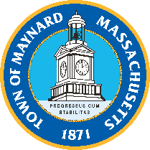
Table of Contents
Introduction 2
Background 3
Accreditation 3
Approach 3
Review of Existing Data 4
CHNA Survey 4
Survey Dissemination 5
Implementation 6
Sustainability 6
Findings 6
Respondent Demographics 7
General Health of the Community 8
Health Concerns in the Community 8
Substance Use in the Community 12
Emergency Preparedness 14
Access to Care 14
Unmet Needs 15
Sources of Information 16
Data Limitations 17
Acknowledgements 17
References 19
Appendix 1: Respondent Demographic Data 21
Appendix 2: 2020 Census Demographic Data 25

Introduction
The health status of a community is more than about delivering quality health care to residents. It is also about the factors of where people live, learn, work, and play. Understanding these characteristics is important for improving a community’s health and informing future priorities. A Community Health Needs Assessment (CHNA) survey is important for identifying community opinions on existing strengths, needs, and health priorities.

Background
In 2024, the Maynard Public Health Division, in collaboration with the Concord Health Division jointly conducted a CHNA to address the following goals for town-specific separate planning:
- Understand the health needs and concerns of the town
- Assist in developing programs and policies to address those needs
- Improve health-related programs and services
- Provide information for town planning processes
- Engage partners, organizations, and individuals in making the vision for a healthier town a reality
This is the first community-specific health survey performed in Maynard in many years, making it pivotal in creating a healthier Maynard. The CHNA results can then be used to inform improvement plans for identified health priorities and resource allocation. Additionally, despite the data being collected jointly, it was analyzed and reported separately.

Accreditation
Public health accreditation is a process that recognizes a health department’s capability to achieve excellence on a set of national standards (Gress, n.d.). The Maynard Public Health Division strives to ultimately obtain accreditation. This CHNA and ensuing Community Health Improvement Plan (CHIP) are foundational steps to reach that goal. Accreditation will benefit Maynard by identifying health priorities, developing a plan to address health needs, and allocating resources. Moreover, accreditation holds the Maynard Public Health Division to continuous quality and performance improvement (Gress, n.d.).

Approach

Review of Existing Data
The Maynard community profile (found on Mass.gov) and Emerson CHNA (2021) were reviewed to describe the various characteristics of the Maynard community. The data included demographics, public health surveillance, vital statistics, and health behaviors. Additionally, the data informed of prior town-specific health priorities such as elderly services, mental health services, chronic diseases, food insecurity, physical activity, and addiction treatment services. Other data sources include the U.S. Census Bureau.

CHNA Survey
The Maynard community profile (found on Mass.gov), Emerson CHNA (2021), and other past community surveys’ data were reviewed to inform town-specific health priorities for survey question development and phrasing. Other surveys included, but were not limited to, 2024 Emerson Youth Risk Behavior Survey (YRBS) and the Adult Substance Use and Driving Survey (ASUDS). The final survey (24 health topic & 12 demographic questions) explored community health topics such as, but not limited to, physical & mental health, substance use, food insecurity, healthcare services, violence, environmental health and social equity factors. Maynard stakeholders reviewed the survey and provided feedback to further refine question topics, phrasing, answer options, formatting within the survey, and local resources for sensitive health topics at the end of the survey. The survey was then copied into the online software Microsoft Forms.
After reviewing town-specific 2022 American Community Survey (ACS) 5-year data, the survey was translated into Spanish (Latin American), Portuguese (Brazilian) and Haitian Creole. Funding for translation was limited and jointly provided by each town or town partner, so languages spoken in both towns had to be considered. For both Concord and Maynard, a majority of surveyed households only spoke English (86.8% and 85.3 %). When examining the households that spoke another language, Spanish and Haitian Creole were among the largest-identified languages. Spanish comprised 25.1% of Concord households that spoke another language or 3.3% of the total Concord household population (total Concord household population is 6,439). Moreover, Spanish comprised 19.9% of Maynard households that spoke another language or 2.9% of the total Maynard household population (total Maynard household population is 4,416). While both town’s overall percentage of households that spoke Spanish were fairly low, it was still the highest percentage language group, and the survey did not want to have additional barriers to completion like lack of language comprehension.
Haitian Creole was selected due to a high percentage of households that speak the language and were identified as a limited English-speaking household, especially in Concord. The U.S. Census Bureau defines limited English-speaking household as one that does not contain individuals (14 years and older) that speak English or speak both a non-English language and English very well (US Census Bureau, 2021). Additionally, at the time of survey design, the Concord Emergency Assistance (EA) shelter housed a large population of Haitian Creole speakers. It was deemed important to translate the survey into this language since lack of English reading and writing comprehension would be a barrier for completion of the CHNA. For Concord, Haitian Creole comprised of 22.5% of households that spoke another language or 3.0% of the total Concord household population. For Maynard, Haitian Creole comprised of 4.0% of households that spoke another language or .59% of the total Maynard household population.
Moreover, we gained feedback from Concord and Maynard stakeholders on common languages that they translate material into and/or interact with. The decision was made not to translate into other languages besides Haitian Creole, Portuguese (Brazilian) and Spanish (Latin American) due to limited resources. The CHNA was then pilot tested among personal and professional networks through digital link, QR code, and paper versions. Participants provided positive feedback on survey length and question topics. Average survey completion time was between 10 and 15 minutes.
The CHNA survey was administered online, through digital links and QR codes, and distributed as paper versions across the Health Division and the Council on Aging (COA) in both towns. It remained open for three months from the beginning of August through the end of October 2024. Participants who indicated that they did not live in either Concord or Maynard on the survey were excluded from the data analysis.

Survey Dissemination
After consulting with town stakeholders, the survey was disseminated through various strategies such as QR code advertising flyers posted both physically and to the internet, a PSA video, phone messaging, event tabling, newsletters, personal networks, and social media. The advertising flyers were posted digitally on the town’s public health division webpages and physically in high-trafficked locations such as the library, Market Basket’s community board, and Planet Fitness. The PSA video, which was roughly a minute in length, was created on Canva and included graphics, videos, and messages informing the CHNA context, purpose, importance of participation, and survey digital link and physical addresses for paper copies. This video was disseminated on town-wide social media (Town of Maynard Facebook page), the official town webpage, and the Maynard Public Health Division webpage.
The phone messaging required a CHNA advertisement blurb that included information on CHNA context, purpose, importance of participation, and survey digital link and physical addresses for paper copies. This worked in partnership with Maynard’s Hyper-Reach platform, which sends voicemail messages to residents that are signed up for the service. A combination of the advertisement blurb, flyer, and QR code were also included in newsletters that community residents subscribe to such as public-school parent and Council on Aging (COA) newsletters. CHNA advertisement materials were also disseminated on popular town-wide social media Facebook groups and neighborhood groups.
Event tabling was used to increase engagement with community members and aid with completing the CHNA survey. This was intended to decrease barriers to completing the survey, as well as to overcome “survey fatigue.” Event tabling was productive, partnered with community events that residents enjoy, like Maynard Fest, or outside shops that residents frequent, like Market Basket. Flyers promoting the survey were made available at the community information table at the Maynard Farmer’s Market and in kiosks around town. A-frames (i.e. sandwich boards) promoting the survey were strategically placed downtown and at back-to-school nights at all schools.

Implementation
Using the findings of the 2024 CHNA, a community health improvement plan (CHIP) will be developed to guide future health-related planning in Maynard.

Sustainability
The Maynard Public Health Division should repeat a CHNA in a few years to analyze if health priorities have changed within the town and if identified community health needs are being addressed adequately. To do so, the Public Health Division needs to review and replicate the CHNA approach process and adapt as needed to new circumstances. The Public Health Division will need to review this assessment report and existing secondary data to identify various community characteristics and potential health priorities to focus on for the next CHNA survey. Question development, phrasing, and formatting within the survey will again need to be considered. Ideally, town division partnerships and community partnerships will continue to grow and allow for enhanced future survey dissemination. Moving forward, it will be necessary to determine the online software best suited for the CHNA survey. The current CHNA used Microsoft Forms, as it was already available to the partnering town of Concord. However, Microsoft Forms had limitations including a lack of question conditional branching logic. This sustainability plan will aid in repeating a CHNA, since it provides a foundation from which to work in the future. Ideally, a future CHNA project would have a larger team and budget to dedicate to the CHNA process and assist in all aspects of the project.

Findings
Overall, Maynard’s 2024 CHNA survey received 354 responses, between the start of August and the end of October 2024. This included 332 (93.8%) collected online and 22 (6.2%) on paper.

Respondent Demographics
 | Age Distribution of Maynard’s Residents Ages 18+* |  | Age Distribution of Survey Responses
 | Count | Distribution | Distribution | Count
18-24 years | 747 | 8.7% | 0.08% | 3 | 18-25 years
25-44 years | 2721 | 31.7% | 33% | 118 | 26-44 years
45-59 years | 2546 | 29.8% | 26% | 93 | 45-60 years
60-74 years | 1764 | 20.6% | 26% | 93 | 61-74 years
75+ years | 800 | 9.3% | 13% | 46 | 75+ years
Total | 8578 | 100% | 99.7%** | 353** | Total
*Source: American Community Survey, 2019–2023, Table B01001
**1 response that did not report age
About 72% of individuals who participated in the survey identified as female, which is a higher proportion of females compared to the composition of those who live in Maynard (49.7% female). The demographic makeup of CHNA survey participants from Maynard, Massachusetts, contrasts with the broader community demographics reported by the American Community Survey (ACS). The CHNA survey predominantly attracted middle-aged adults (26-44 and 61-74 years), whereas the ACS data shows a more even distribution across all age groups, including younger adults and the elderly. This discrepancy highlights an underrepresentation of the community's youngest (18-25 years) and oldest (75+ years) members in the health survey. Additionally, the survey was heavily skewed towards female respondents, who comprised 72% of participants, compared to the nearly balanced gender distribution in the ACS data. This overrepresentation of females could lead to a biased understanding of community health needs, affecting the accuracy and effectiveness of local health initiatives. Given that the demographics of survey respondents differ from the broader community demographics reported by the ACS or census, data from this survey cannot be generalized to the entire town. However, the 354 survey responses are still valuable and provide important insight into community health needs.

General Health of the Community
In Maynard, about 84.2% of participants rated their physical health as either “good or “very good,” and about 3.1% rated theirs as “poor”. Additionally, 74.4% of participants rated their mental health as either “good” or “very good.” It should be noted that no participants rated their physical or mental health as “very poor”. When asked to disclose disability status, 187 (52.8%) participants reported having at least one disability.
The ACS data indicates that cognitive difficulties are the most reported impairment at 7.1%, followed by ambulatory difficulties at 5.6%, and hearing difficulties at 3.9%. In contrast, the local health survey reports higher rates of impairment related to behavior or emotional conditions (72 counts), which is not explicitly broken down in the ACS data. The local survey also highlights mobility (61 counts) and hearing (69 counts) as major concerns, aligning with the ACS data in terms of these being significant issues but showing a higher immediate concern in the survey responses.

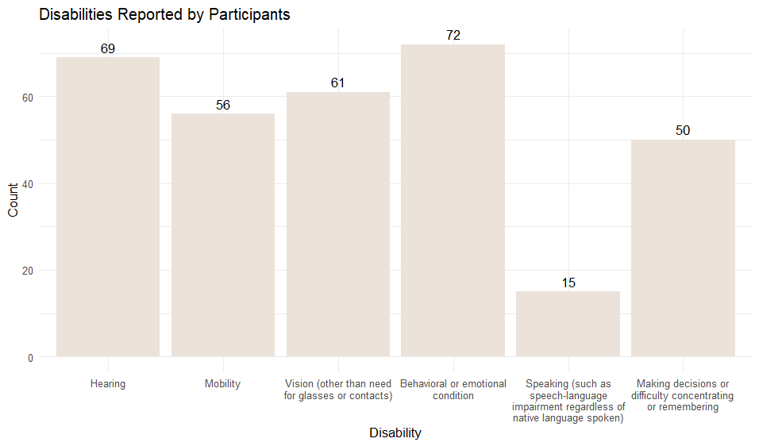
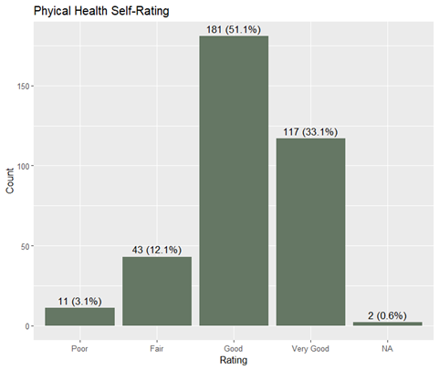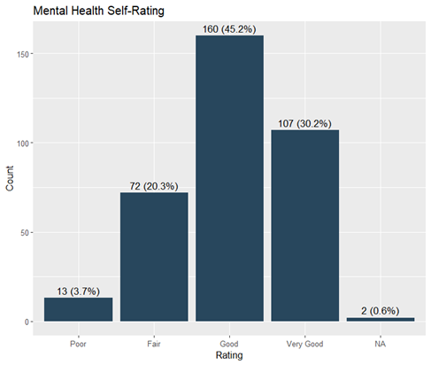

Health Concerns in the Community

Physical Health Conditions
Survey participants were presented with a series of prompts and instructed to rate the level of concern for themselves and their household. Pertaining to issues regarding physical health, participants expressed the most concern for dental and oral health, hypertension, heart disease, cancer, and age-related conditions. In all these categories, over 50 percent of participants reported some level of concern regarding these issues.

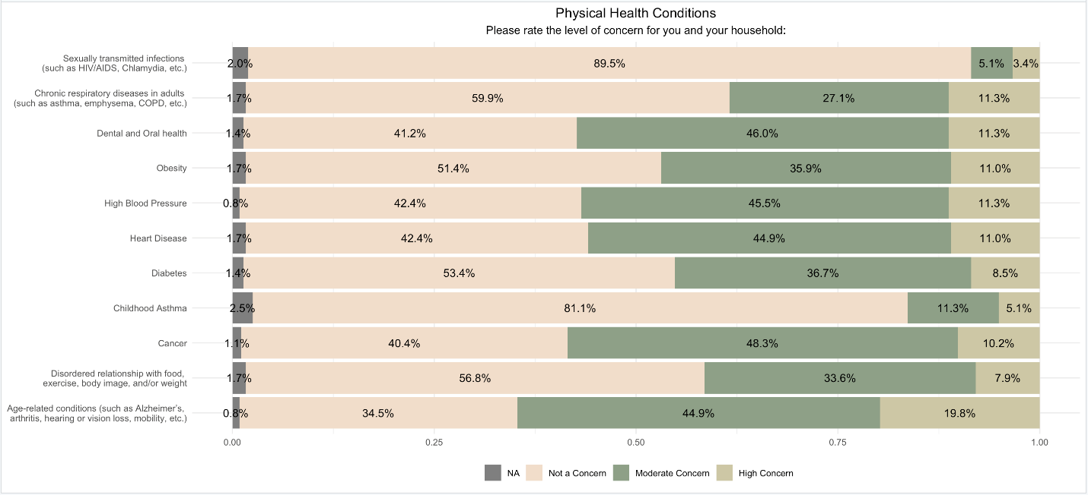
Behavioral Health
When prompted to rate their concerns about behavioral health issues, over 50 percent of participants reported some concern about mental health conditions such as depression, anxiety, and bipolar disorder. In an open response, some participants also expressed concerns about mental health care for children. They pointed to lack of resources in schools and long waitlists for care as issues.

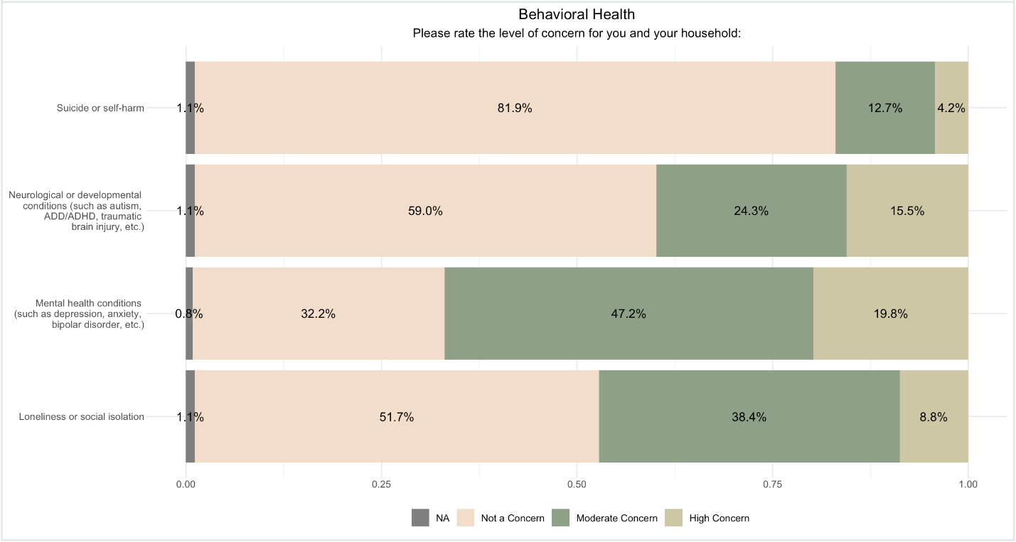
Violence, Safety, & Injuries
In regard to violence, safety, and injuries, many participants expressed concern over pedestrian and bicycle safety. When given the opportunity to further express their concerns, respondents pointed to poor road conditions (i.e. potholes) and feeling that some individuals are not obeying traffic laws.
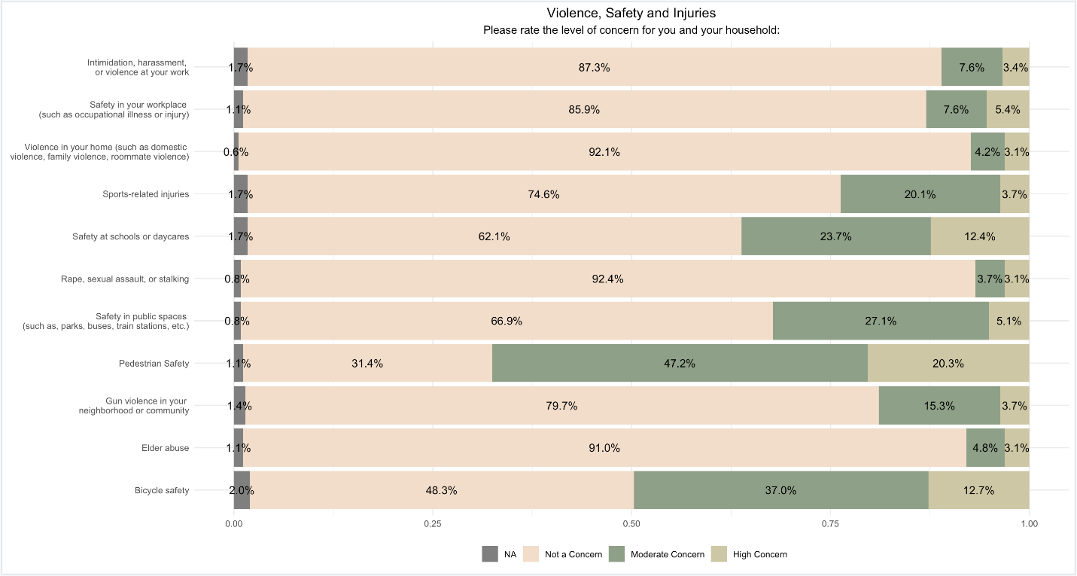

Environmental Health
Participants also reported many concerns about environmental issues. When prompted, over 50 percent of participants reported concerns about climate change, food safety, healthy homes (i.e. indoor air quality, pests, mold/moisture, etc.), and exposure to harmful materials in soil, drinking water, air, or consumer products. In the open response question, some respondents expressed concerns about water and sewer issues.
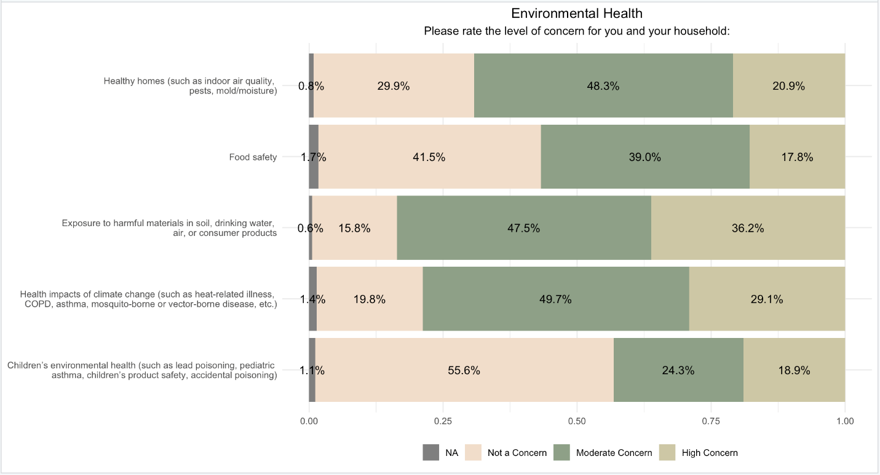
Social Factors
Regarding social factors, over 50 percent of participants reported concerns over lack of public transportation and lack of affordable housing. In the open response question, respondents expressed concerns about the rising costs of living combined with stagnant wages.

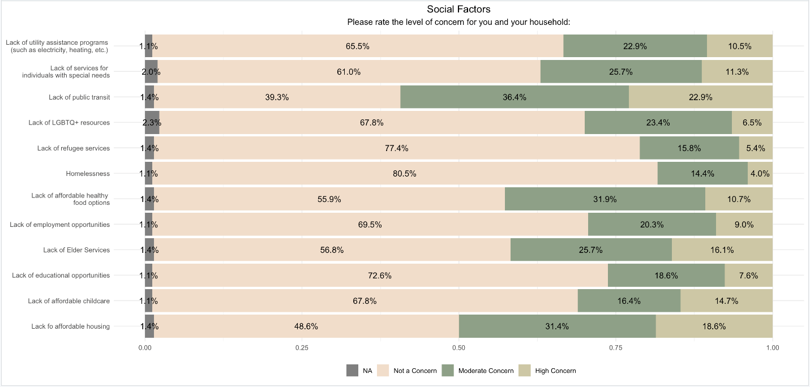
Social Justice & Equity Factors
In the open responses, several participants voiced that inclusivity, and a welcoming atmosphere are crucial for the community, emphasizing the importance of making all members feel included, regardless of personal impact. Additionally, there were mixed feelings about the presence of undocumented immigrants and concerns that focusing intensely on minority groups might overshadow broader community needs. These responses highlight the diversity of opinions in the community and underscore the need for balanced discussions that address various perspectives while fostering an inclusive environment.

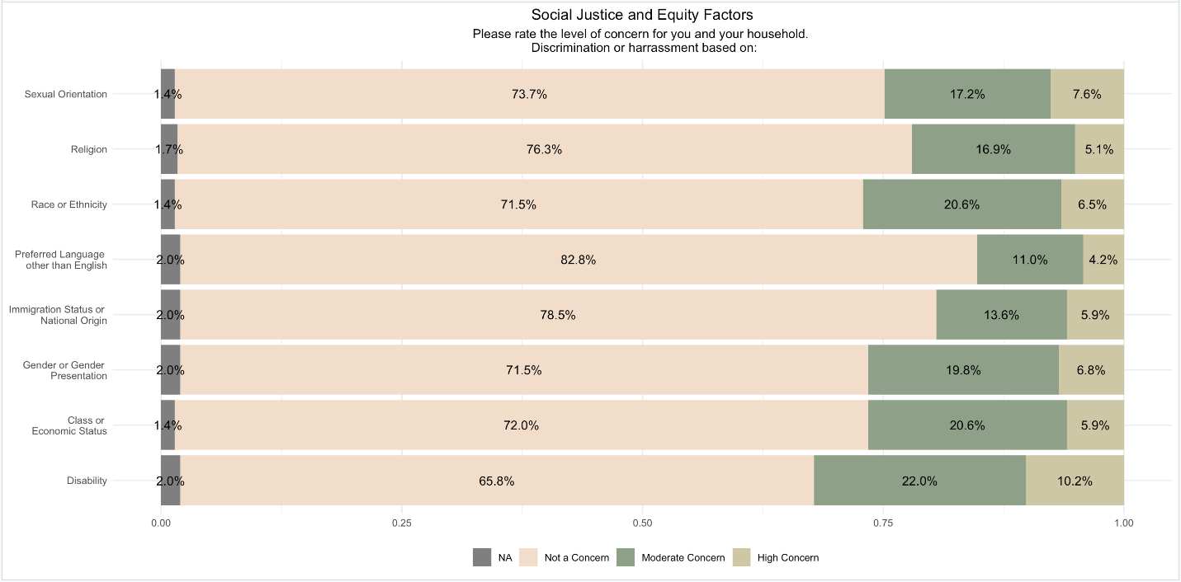

Substance Use in the Community
The survey also asked participants about their, and their household’s, alcohol and substance usage. In addition to the figure above, about 3.4% of participants reported that either they or someone in their household experienced a drug overdose in the past year. Furthermore, of those who reported themselves or members of their household as having experienced an overdose, about 33% indicated that Naloxone (Narcan) was administered by a friend, family member, or bystander.
Among Maynard respondents, the substance use patterns are diverse, with a notable percentage of the population engaging in various levels of substance use. While 84% of respondents report never using marijuana/cannabis, the usage rates for alcohol are more varied: 48% of respondents do not drink alcohol at all, 40% consume 1-4 alcoholic beverages per week, and a smaller segment reports higher consumption rates, with 10% drinking between 5-9 drinks weekly and 2% consuming over 10 drinks per week. This is a total of 52% of respondents reporting that they consume alcohol on a weekly basis. The CDC defines excessive drinking as 8 or more drinks a week for women, or 15 or more drinks a week for men (CDC, 2024). Excessive drinking has the risk of injury or death due to motor vehicle accidents, alcohol poisoning, or violence. However, excessive drinking also has long term health effects. According to General Surgeon’s 2025 report on Alcohol and cancer risk, alcohol consumption increases the risk of 7 types of cancer. Despite these figures, a significant majority (81%) express no concern about their substance use. Eighty-five percent of respondents report that others are not concerned about their personal substance use. Respondent reports of tobacco and opioid use are markedly low, with the vast majority reporting no use. These data points highlight the complexity of substance use behaviors and the varying degrees of concern among Maynard respondents.
In Massachusetts, the Department of Health (DPH) collects data on smoking prevalence throughout the state. Based on data collected through electronic medical records, DPH reports that the smoking prevalence in Maynard is 8.5%, and based on data collected through the CDC Behavioral Risk Factor Surveillance System (BRFSS), smoking prevalence in Maynard is 9.8%. Based on the data collected during the 2024 CHNA, the percentage of participants who report any tobacco use was about 9%.

 | Never | 1-4 times per week | 5-9 times per week | Over 10 times per week
Marijuana/Cannabis | 294 (84%) | 35 (10%) | 17 (4.9%) | 4 (1.1%)
 | Never | 1-4 drinks per week | 5-9 drinks per week | Over 10 drinks per week
Alcohol | 168 (48%) | 139 (40%) | 35 (10%) | 7 (2.0%)
 | Never | Occasionally (A few times in the past year) | Regularly (More than 2 times in a month) | Always (Daily)
Tobacco | 320 (91%) | 16 (4.5%) | 11 (3.1%) | 5 (1.4%)
Opioids (not prescribed and/or using more than prescribed) | 337 (96%) | 11 (3.1%) | 1 (0.3%) | 1 (0.3%)
Other drug or substance | 326 (93%) | 17 (4.9%) | 5 (1.4%) | 2 (0.6%)
 | Not Concerned | Somewhat Concerned | Very Concerned | N/A
How concerned are you about any of your substance use? | 283 (81%) | 23 (6.6%) | 11 (3.2%) | 32 (9.2%)
What is the level of concern others have had about your substance use? | 296 (85%) | 9 (2.6%) | 13 (3.7%) | 31 (8.9%)
Are you concerned about active substance use by others in your household? | 274 (79%) | 26 (7.5%) | 18 (5.2%) | 30 (8.6%)

Emergency Preparedness
In the survey, participants were asked questions to gauge how prepared their households are in case of emergency. When asked if their household had a three-day supply of essential items in case of an emergency, 23.6% of participants reported that they did not or were unsure. Furthermore, 30% of participants indicated that in an emergency, they did not know or were unsure if a neighbor or community member would come check on them. It should be noted that when stratified by age, this was consistent across all age groups. Moreover, those who reported having a three-day supply of essential items were almost twice as likely to report having a neighbor or community member who would come check on them in an emergency.
 | Yes | No | Unsure
Does your household have a 3- day supply of essential items in case there is an emergency (such as food, water, clothing, batteries, prescription medicine, personal hygiene items, etc.)? | 68 (19%) | 54 (15%) | 30 (8.6%)
If there were an emergency today, do you know a neighbor or community member that  would check on you and your household? | 244 (70%) | 68 (19%) | 39 (11%)

Access to Care
In Maynard, about 90% of participants reported having a Primary Care Physician (PCP) and/or dentist. It should be noted, though, that 24% (n = 83) of participants reported having difficulty getting medical, dental, or mental health services for themselves or their household when they needed them. Among this group of participants, when asked about the reasons they were struggling to access care, the most commonly cited barriers were difficulty finding providers that accept their insurance (n = 40, 48.2%), long wait times for appointments (n = 37, 44.6%), high cost of insurance (n = 28, 33.7%), lack of coverage for needed specialists (n = 18, 21.7%), not having insurance (n = 13, 21.7%), provider hours not working with their schedule (n = 12, 14.5%), not knowing what their insurance covers (n = 12, 14.5%), and not knowing where to get services or how to find a provider (n = 12, 14.5%).

 | Yes | No | Unsure
Do you and your household have a regular healthcare provider (a primary care provider like a medical doctor or nurse practitioner) who you can visit for check-ups or when you are sick? | 321 (91%) | 24 (6.8%) | 7 (2.0%)
Do you and your household have a regular dentist you go to for dental care and oral health (e.g.  cleanings and treatment)? | 316 (90%) | 35 (9.9%) | 2 (0.6%)

Access to Mental Health Services

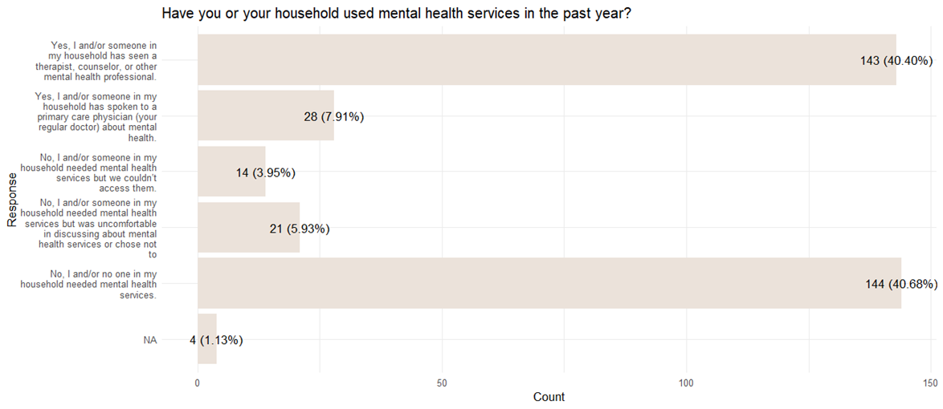
Participants were also asked if they or anyone in their household had accessed mental health services in the past year. About 48.31% (n = 171) of participants reported either seeing a mental health professional or discussing it with their PCP, 3.95% (n = 14) reported needing services but not being able to access them, and 5.93% (n = 21) reported needing services but felt uncomfortable discussing mental health or chose not to. Additionally, 12.1% of participants indicated that they or someone in their household had experienced thoughts of suicide or harming themselves in the past year. Further, 15.9% of participants indicated that they or someone in their household experiences difficulty parting with possessions, resulting in clutter that substantially compromises the intended use of living areas in their home.

Unmet Needs
In the survey, participants were asked a series of questions to evaluate the socio-economic needs of the community. The questions asked included: their ability to afford food, their ability to afford their rent/mortgage and other necessities, and usage of public benefits. In Maynard, about 14.2% of participants indicated (at varying degrees) that at some point within the last year, their food supply ran out and their household did not have money to buy more. Additionally, about 29.7% of participants indicated (at varying degrees) that at some point within the last year their household worried about being able to pay their rent/mortgage, while having enough money left over for other necessities.
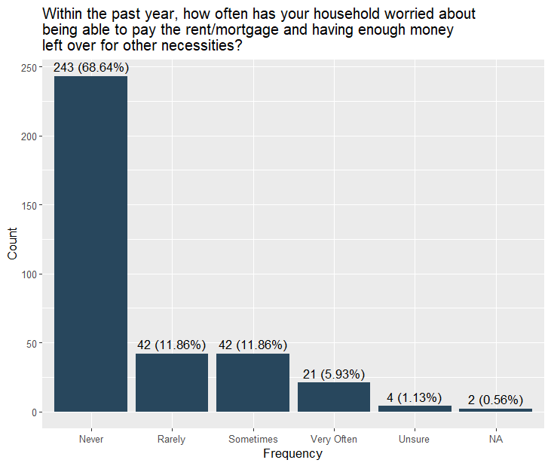
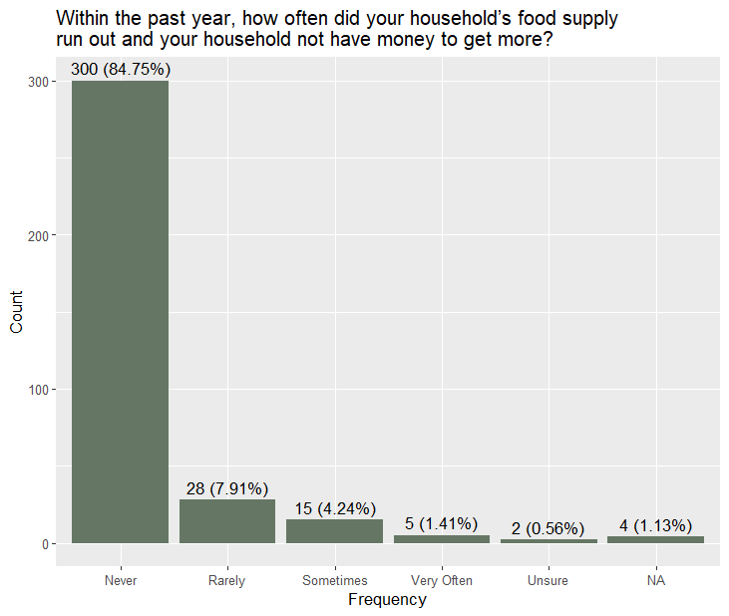
Public Benefits | Yes | No | Unsure | I think I may qualify but don’t know how to access them
Disability benefits (such as SSI, SSDI, etc.) | 23 (6.7%) | 312 (91%) | 5 (1.5%) | 4 (1.2%)
SNAP (food stamps) | 30 (8.7%) | 308 (89%) | 2 (0.6%) | 5 (1.4%)
Fuel Assistance (such as LIHEAP, etc.) | 17 (4.9%) | 309 (90%) | 5 (1.4%) | 14 (4.1%)
Economic Assistance (such as TAFDC, EAEDC, etc.) | 16 (4.6%) | 320 (93%) | 6 (1.7%) | 3 (0.9%)
Financial Household Assistance (such as RAFT, HomeBASE, etc.) | 15 (4.4%) | 316 (92%) | 6 (1.7%) | 7 (2.0%)
Discounted Internet and Phone Service (such as Lifeline, etc.) | 20 (5.8%) | 312 (90%) | 3 (0.9%) | 11 (3.2%)
Senior Means Tested Tax Exemption (For real estate) | 10 (2.9%) | 317 (92%) | 9 (2.6%) | 9 (2.6%)
Discounted light and water bills (Residential Assistance Discount Rate) | 15 (4.4%) | 307 (90%) | 7 (2.0%) | 14 (4.1%)

Sources of Information
In the survey, participants were asked to indicate where they are most comfortable seeking resources, support, and/or information. These results were then stratified to show those ages 18-60 and over the age of 60, separately. These results can, in the future, aid the Public Health Division in determining effective modes of communication and/or resource sharing with residents.

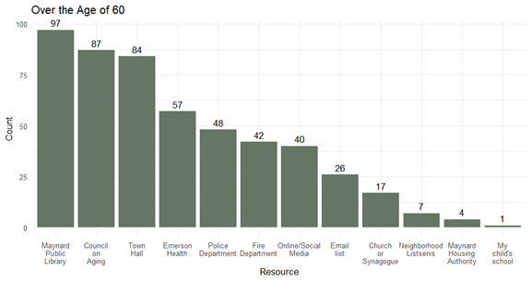
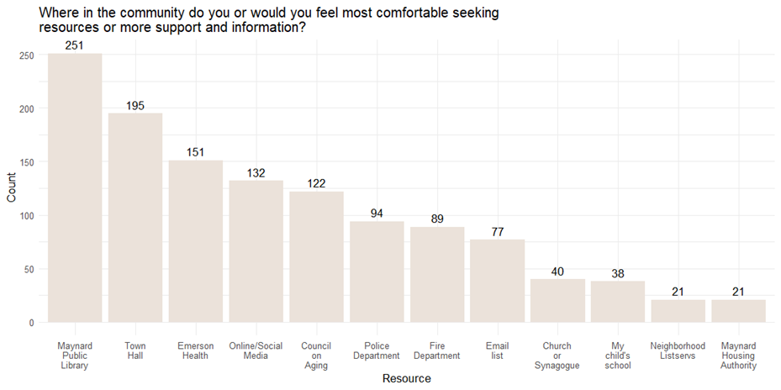
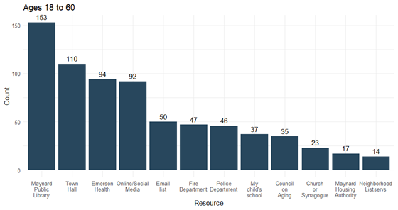

Data Limitations
The Maynard Public Health Division faced challenges related to survey design, promotion, and resource limitations, which likely impacted survey participation. Acknowledging limitations is important in considering possible improvements for future surveys.

Key Points:
- Anonymity Concerns: A few Concord residents expressed distrust in the survey's anonymity, which may have deterred participation. The impact of this concern on overall participation in Maynard is unknown.
- Survey Length and Sensitive Questions: The length of the survey and the inclusion of sensitive questions are also cited as potential barriers to completion.
- Sample Size and Sampling Bias: The respondent pool is not a perfect representation of all Maynard residents.
- Self-Reporting Errors or Self-Report Bias: Questions can be interpreted differently by different people, leading to misinterpretations and inaccurate responses (Salters-Pedneault, 2025). People may have difficulty accurately remembering past events or experiences, leading to errors in their reports (Althubaiti, 2016). Individuals may be prone to certain response patterns, such as always selecting middle or extreme responses (Salters-Pedneault, 2025). Some people may not be able to accurately assess themselves or their behaviors (Salters-Pedneault, 2025).
- Lack of Motivation: Lack of motivation within the community to complete the survey potentially decreased response rate.
- Promotion Efforts: While the Public Health Division actively promoted the survey through various channels, the Division acknowledges it was not enough to reach everyone.
- Ideal Scenario: Direct Mail: Mailing the survey (with a prepaid return envelope) or an advertisement directly to all residents would have been ideal for maximizing reach, but budget constraints prevented this.
- Limitations of the CHNA: The CHNA could have benefited from focus groups and key stakeholder interviews, but these were not feasible due to capacity limitations.
- Stakeholder Involvement: Despite these limitations, the Public Health Division did collaborate with key stakeholders during the survey design and promotion phases to ensure relevant questions and maximize community engagement.
- Aging in Maynard Survey: In Spring 2024, a community needs assessment commissioned by the Town of Maynard and the Maynard Council on Aging (COA) was conducted and surveyed Maynard residents aged 50 and older to identify and plan for the needs, interests, preferences, and opinions of the Town’s 50+ population. Though the Aging in Maynard survey did not run concurrently with the Maynard Public Health Division’s 2024 CHNA, and the Maynard Public Health Division worked closely with the COA to separately advertise the 2024 CHNA, there may have been some residents who participated in the Aging in Maynard survey that did not participate in the CHNA thinking they had already participated.
- Potential Solution: Shorter Surveys: The Maynard Public Health Division proposes that two shorter surveys might have yielded higher completion rates.

Acknowledgements
2024 Massachusetts Department of Public Health Local Public Health Intern
Jefferson Xu (MPH Candidate at Boston University)
Boston University MPH Candidates and Health Division Interns
Gabriela Stack
John Comosa
Sana Shaikh
Maynard Public Health Division
Ivan Kwagala – Director
Moira Carter – Public Health Nurse
Special thanks to the following Town and community partners
Domestic Violence Services Network, Inc.
Eliot Community Human Services
Emerson Health
Great Meadows Public Health Collaborative
Massachusetts Organization for Addiction Recovery
Maynard Boards and Committees
Maynard Council on Aging
Maynard Fire Department
Maynard Housing Authority
Maynard Office of Municipal Services
Maynard Police Department
Maynard Public Library
Maynard Public Schools
Maynard Residents
Maynard Town Administrator’s Office
MetroWest Shared Public Health Services
Open Table

References
Alcohol and Cancer Risk. (2025, January 17). HHS.gov. https://www.hhs.gov/surgeongeneral/reports-and-publications/alcohol-cancer/index.html
Althubaiti, A. (2016). Information bias in health research: definition, pitfalls, and adjustment methods. Journal of multidisciplinary healthcare, 9, 211–217. Althubaiti, A. (2016). Information bias in health research: definition, pitfalls, and adjustment methods. CDC. (2024, May 23).
Centers for Disease Control and Prevention. (2025, January 14). Understanding alcohol use. U.S.Department of Health & Human Services. https://www.cdc.gov/alcohol/about- alcohol-use/index.html#cdc_behavioral_basics_warning_signs-understanding-alcohol- use
Gress, A. (n.d.). Accreditation & Recognition. Public Health Accreditation Board. https://phaboard.org/accreditation-recognition/
Salters-Pedneault, K. (2025, February 16). Can psychological self-report information be trusted? . Verywell Mind. https://www.verywellmind.com/definition-of-self-report-425267
US Census Bureau. (2021, December 3). Frequently Asked Questions (FAQs) About Language Use. Census.gov. https://www.census.gov/topics/population/language-use/about/faqs.html#:~:text=A%20%22limited%20English%20speaking%20household
U.S. Census Bureau, U.S. Department of Commerce. (2023). Sex by Age. American Community Survey, ACS 5-Year Estimates Detailed Tables, Table B01001. Retrieved December 30, 2024, from https://www.data.census.gov/table/ACSDT5Y2023.B01001?q=B01001: Sex by Age&g=060XX00US2501715060
U.S. Census Bureau. (2023). Age and Sex: Maynard CDP, Massachusetts. American Community Survey, ACS 5-Year Estimates Data Profiles, Table DP05. Retrieved March 10, 2025, from https://data.census.gov/table/ACSDP5Y2023.DP05?q=Maynard+CDP,+Massachusetts.

Appendix 1: Respondent Demographic Data
Characteristic | Maynard  N = 354¹
Age
18-25 | 3 (0.8%)
26-44 | 118 (33%)
45-60 | 93 (26%)
61-74 | 93 (26%)
75+ | 46 (13%)
Prefer not to answer | 1 (0.3%)
Gender Identity
Male | 85 (24%)
Female | 255 (72%)
Non-Binary | 5 (1.4%)
Prefer to self-describe | 3 (0.8%)
Prefer not to answer | 6 (1.7%)
Transgender
No | 336 (95%)
Yes | 13 (3.7%)
Prefer not to answer | 5 (1.4%)
Sexual Orientation
Straight or Heterosexual | 290 (82%)
Lesbian, Gay, or Homosexual | 16 (4.5%)
Bisexual | 28 (7.9%)
Prefer to self-describe | 5 (1.4%)
Prefer not to answer | 15 (4.2%)
Hispanic | 9 (2.5%)
Race
White | 308 (87%)
Black or African American | 2 (0.6%)
American Indian or Alaskan Native | 2 (0.6%)
Asian | 8 (2.3%)
Middle Eastern of North African | 2 (0.6%)
Native Hawaiian or other Pacific Islander | 1 (0.3%)
Unsure | 2 (0.6%)
Other or Multi-Racial | 21 (5.9%)
Prefer not to answer | 8 (2.3%)
Household Size
1 | 66 (19%)
2 | 127 (36%)
3 | 80 (23%)
4 | 59 (17%)
5+ | 22 (6.2%)
Income
Less than $25,000 | 15 (4.2%)
$25,000 to $34,999 | 13 (3.7%)
$35,000 to $49,999 | 20 (5.6%)
$50,000 to $74,999 | 40 (11%)
$75,000 to $99,999 | 49 (14%)
$100,000 to $149,999 | 67 (19%)
$150,000 or more | 107 (30%)
Unsure | 8 (2.3%)
Prefer not to answer | 35 (9.9%)
Current Living Situation
A house, condo, or apartment owned by me or my household | 304 (86%)
A house, condo, or apartment rented by me or my household | 41 (12%)
Nursing Home or Elder Care Facility | 1 (0.3%)
University or other school dormitory | 0 (0%)
Temporary housing (shelter, motel, etc.) | 0 (0%)
A halfway house or residential program | 1 (0.3%)
My household and/or I are staying with someone at their house/apartment | 2 (0.6%)
Homeless/Unhoused | 0 (0%)
Other | 5 (1.4%)
Living in affordable housing (among those who rent) | 13 (32%)
Primary Language Spoken in the Home
English | 346 (97.7%)
Spanish | 1 (0.3%)
Mandarin | 1 (0.3%)
Cantonese | --
French | 1 (0.3%)
Haitian Creole | --
Portuguese | 2 (0.6%)
Hindi | --
Japanese | --
Greek | --
Bulgarian | --
Prefer not to answer | 3 (0.8%)
Education
No schooling completed | --
Grades 1-8 (elementary) | 3 (0.8%)
Grades 9-11 (some high school) | 4 (1.1%)
Grade 12 or GED (high school graduate) | 14 (3.95%)
College 1 year to 3 years (some college) | 38 (10.7%)
Associate’s degree (for example: AS, AA) | 17 (4.8%)
Bachelor’s degree (for example: BA, BS) | 121 (34.2%)
Master’s degree (for example: MA, MS, MEng, MEd, MSW, MBA) | 129 (36.4%)
Professional degree beyond a bachelor’s degree (for example: MD, DDS, DVM, LLB, JD) | 14 (3.95%)
Doctorate degree (for example: PhD, EdD) | 12 (3.4%)
Prefer not to answer | 2 (0.06%)
Employment (select all that apply)
Employed for wages | 202 (57%)
Self-employed | 43 (12.1%)
Unemployed | 9 (2.5%)
Homemaker | 17 (4.8%)
Student | 2 (0.6%)
Retired | 10 (29.9%)
Volunteer | 3 (8.8%)
Unable to work | 10 (2.8%)
Prefer not to answer | 3 (0.08%)
Other | 8 (2.3%)
Survey Language
English | 351 (99%)
Portuguese | 2 (0.6%)
Spanish | 1 (0.3%)
Survey Format
Online | 332 (93.8%)
Paper | 22 (6.2%)
¹ n (%)

Appendix 2: 2020 Census Demographic Data
Characteristic | Maynard
Age
Under 5 | 4%
Under 18 | 19.6%
19-64 | 60.9%
65+ | 15.5%
Gender Identity
Male | 50.2%
Female | 49.8%
Race
White | 84.5%
Black or African American | 1.4%
American Indian or Alaskan Native | 0%
Asian | 5.9%
Native Hawaiian or other Pacific Islander | 0%
Hispanic or Latino | 3.5%
Two or More Races | 7.1%
Families and Living Arrangements
Persons Per Household 2019-2023 | 2.27
Households 2019-2023 | 4,673
Language other than English spoken in the home by persons age 5+ years 2019-2023 | 11.9%
Education
Highschool graduate or higher, percent of persons age 25+ years 2019-2023 | 96.1%
Bachelor’s degree or higher, percent of persons age 25+ years 2019-2023 | 64.2%
Employment
In civilian labor force, total, percent of population age 16+ years 2019-2023 | 72.4%
Income
Median household income (in 2023 dollars), 2019-2023 | $119,549
Per capita income in the past 12 months (in 2023 dollars) 2019-2023 | $66,632
Persons in poverty, percent | 7.4%

